Individual Number (My Number) Entry Form
Please fill in the following items.
Address |  |  |  |  |  | City/ward/town/village
Address | ^{Building name, etc.}
Parent/guardian 1 | Name |  |  |  |  |  |  |  |  |  |  |  | Date of birth (YY/MM/DD)
Parent/guardian 1 | Furigana
Parent/guardian 1 | Individual number
Parent/guardian 2 | Name |  |  |  |  |  |  |  |  |  |  |  | Date of birth (YY/MM/DD)
Parent/guardian 2 | Furigana
Parent/guardian 2 | Individual number

Child 1 | Name |  |  |  |  |  |  |  |  |  |  |  | Date of birth (YY/MM/DD)
Child 1 | Furigana
Child 1 | Individual number
Child 2 | Name |  |  |  |  |  |  |  |  |  |  |  | Date of birth (YY/MM/DD)
Child 2 | Furigana
Child 2 | Individual number
Note: This form is submitted pursuant to Article 14, Paragraph 1 of the Act on the Use of Numbers to Identify a Specific Individual in Administrative Procedure (Act No. 27 of 2013). Your individual number will not be used beyond the scope necessary for processing matters related to this application, in accordance with Article 9, Paragraph 2 of the Act, and Article 4, Paragraph 1, Item 1 of the Musashino City Ordinance on the Use of Individual Numbers and Specified Personal Information (Musashino City Ordinance No. 58 of December 2015), as well as Item 7 of Appendix 1 in the same ordinance.
For administrative use  (reception desk only) | □ Personal identification documents and the individual number cards have been visually verified.

Continues on back
１ Please attach a copy of a personal identification document for Parent/guardian 1 to the front.
(1) Only one document is required  Ａ  ・ Driver’s license  ・ Passport  ・ Individual number card (copy of front)  Note: Notification cards are not accepted as personal identification.  ・Residence card, etc. | (2) Two documents are required  Note: Attach two documents from category B, or one from B and one from category C.
  B: Government-issued documents without photos  ・ Insurance cards  ・ Pension handbooks  ・ Medical certificates  ・ Welfare recipient certificate, etc. | C: Photo IDs issued by a private organization  ・ Student IDs, employee IDs, etc.  ・ National or local government-issued qualification certificates with photo (excluding items listed in A).
Attach the first document
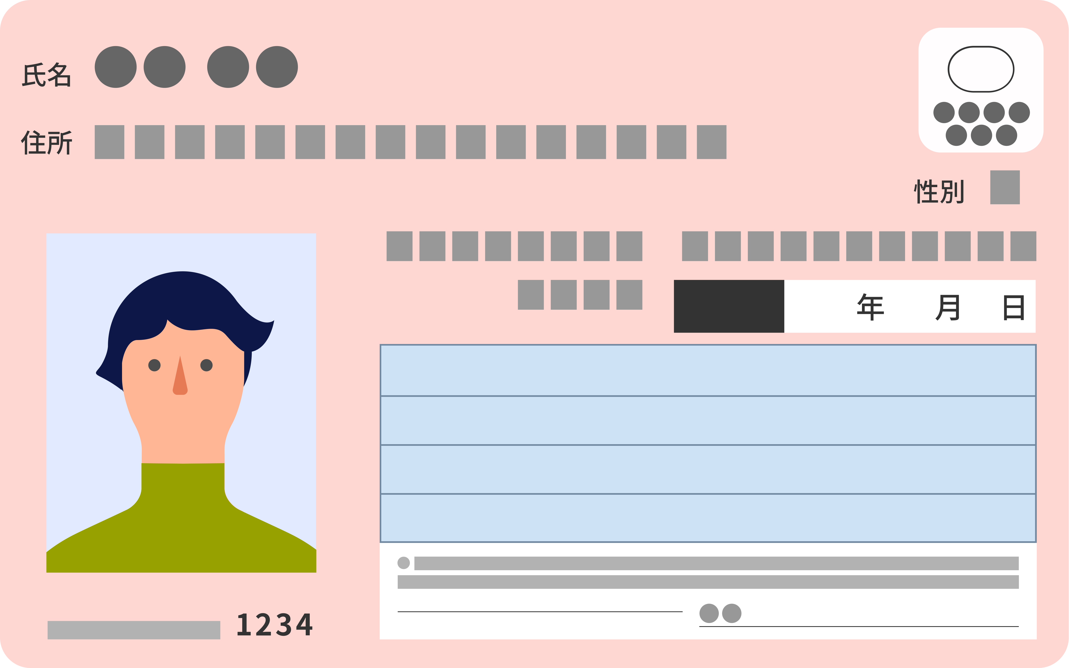
Attach the second document

健康保険
資格確認書
２ Please attach a copy of one of the following four documents to verify your individual number.
1) A copy of the back of your individual number card
2) A copy of the individual number notification card that lists your current name and address
3) A copy of your resident record that lists your individual number
4) A certificate of items stated in your resident record that lists your individual number
Please note that the individual number notification letter is not accepted as a verification document.
Parent/guardian 1 — Attach here  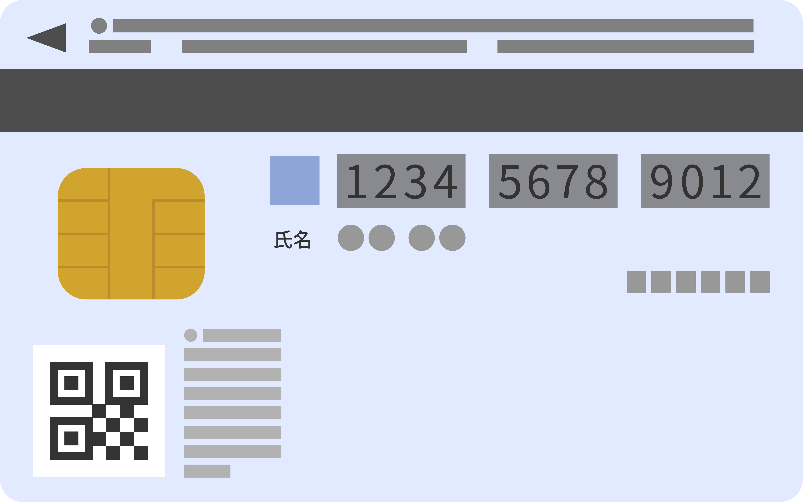 |  | Parent/guardian 2 — Attach here
Child 1 — Attach here |  | Child 2 — Attach here
If you do not have a document to verify your individual number, please check the box below (☑).
□ I consent to Musashino City verifying my individual number at its discretion for this application as necessary.
Note: Even if you check this box, you must still enter your individual number on the front.

